Narrative Designer Test – Characters – Martijn Herrman (February 2026)


Q2: Character Framework Design
Character Profile 1: HANAKO.
Name | Hanako Nakai | 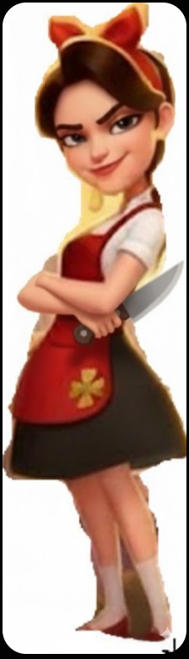
Gender | Female
Age | 21
Race | East-Asian: Japanese
Height | 160 cm
Weight | 50 kg
Hair | Black
Eyes | Dark brown
Clothing and special features | As in the reference image.  Hanako is always holding one or two large kitchen knives.  Idle animation: Hanako juggles with her knives.
Character traits | - Introverted  - Sinister, macabre  - Serious and righteous  - Hard-working  - Ambitious  - Highly intelligent
Motivation | Become a chef in less than 2 years
Favorite Cuisine | Japanese: Sushi.
Hobby | - Act as a living statue of a crying onion cutter in Montmartre, the art area of Paris.  - Reading French literature and philosophy: Simone de Beauvoir.
Voice | Wednesday Addams.

Backstory:
Daughter of two Japanese restaurant owners in Paris. She lost her parents in a car accident when she was 12, which traumatized her. The restaurant – her home – got sold, and Hanako was placed in a French foster family. The foster family did their best, but they were very bad at cooking. Hanako taught herself to cook, first only for herself and later on also for her foster parents.
Losing her parents caused Hanako’s dark side to develop, which is why she juggles knives and has a slightly sinister, intimidating demeanor to people she doesn’t know very well. The trauma also caused her to be introverted and gave her the feeling that she had to fend for herself.
The trauma also made her get into reading. Reading Simone de Beauvoir’s work made her a very independent person and a feminist, adopting De Beauvoir’s viewpoint that society is created by men, for men, who deliberately made the position of women submissive. She can’t stand that women are traditionally considered to be the person who cooks in a household, while chefs are most often men. Hanako prefers to work with female coworkers and superiors, and will grab every competition to show women can beat men in anything – cooking, or otherwise.
Character Profile 2: NICK.
Name | Nick Francis | 
Gender | Male
Age | 21
Race | African-American
Height | 190 cm
Weight | 85 kg
Hair | Black
Eyes | Brown
Clothing and special features | As in the reference image.  His bare arms show off his athletic appearance.  Nick is wearing headphones.
Character traits | - Extroverted  - Lazy, spoiled  - Funny, frivolous  - Independent  - Not afraid to cheat to achieve goals
Motivation | - Gain a Michelin star at minimum effort
Favorite Cuisine | American: T-Bone Steak with Fries
Hobby | - Music: works as a DJ in a discotheque in the Paris nightlife.  - Going on multi-day hikes and harvesting herbs.
Voice | Joey Tribbiani

Background story:
Nick is a trouble-making kid from a wealthy family of doctors living on the outskirts of New York; his mother was a dietitian. Meals were always prepared with utmost care.
Where Nick was, trouble followed. Nick was a naughty boy who didn’t want to listen to his parents. He spent a lot of time outside, hanging out or hiking with friends. When hiking, Nick had a special attention for which herbs, plants, fruits, and fungi were edible (or not). He would sometimes bring stuff home to ask his mother about it.
Nick refused to go on holiday with his parents from the age of 16, and instead traveled to places by himself or with a friend. His travels have taken him to the USA’s Midwest, to Africa, Thailand, and Europe – all paid for by his parents. His parents also pay for his studies at a Hotel School in France, where he majors in Culinary Arts.

