School Quest World
Short overview
- Earth-like planet
- Islands
- Each island offers something different (e.g., land, volcano, cave, and so on).
- Subtropical climate
- Inhabited by normal people
- Technology: Contemporary earth technology.
- There is airfare, but the main transportation between the islands is by boat.
- Magic: No magic, but there is voodoo-like stuff that technology can't explain.
- People's culture: The islands are isolated from the rest of the planet. Except for the player character's father, there are no characters from outside the island communities.
- There is a legend about voodoo, but the people laugh about it.
- The isolation has led to particularities in the way people go about their business.
- People's origin:
- The people on the island are native to the islands, except:
- The Player character, who is (literally) dropped onto the first island and originates from an airship.
- Jackie's Mother imitates the legends in her evil deeds, but her voodoo is, in fact, fake.

World Appearance
Island List
- Village Island
- School Island
- Rocky/Castle Island
- Cave Island
- Lighthouse Island

General appearance of the islands
Islands have a Pacific subtropical climate.
Model: La Reunion
- https://julial3fle.wordpress.com/faune-et-flore/
- https://habiter-la-reunion.re/la-flore-de-la-reunion/

Coast
Cliffs and beaches.
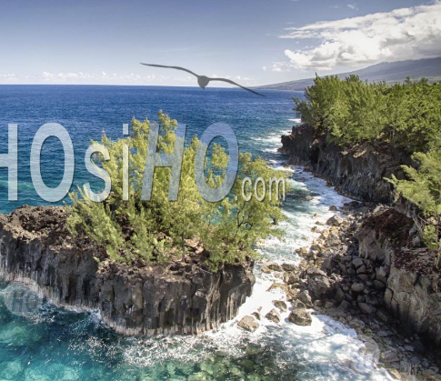 | 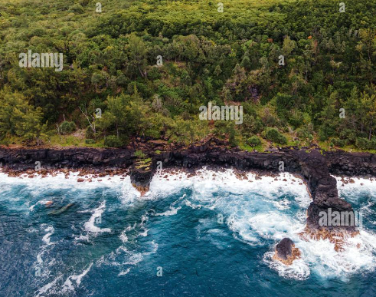

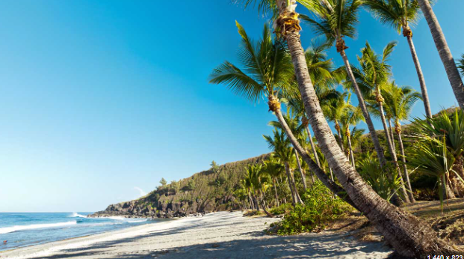 | 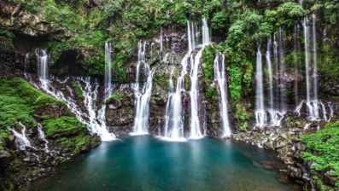

Vegetation
Trees: Palms, ferns, leaf trees.
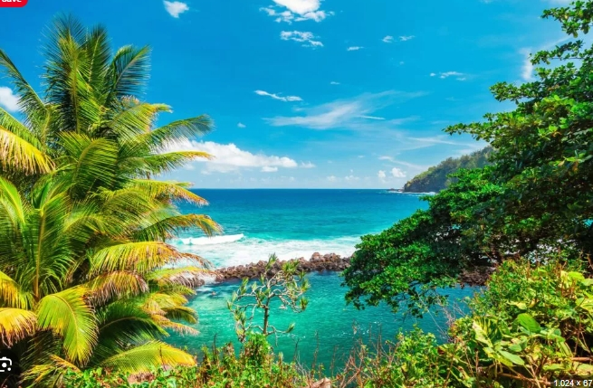 | 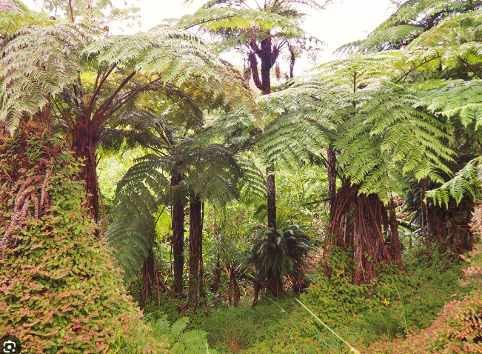

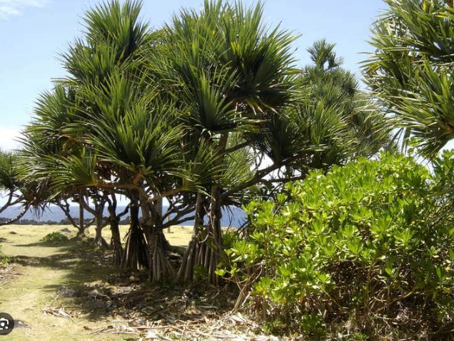 | 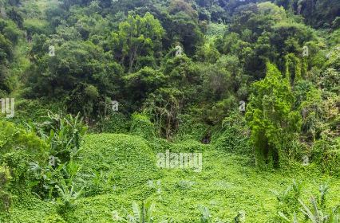
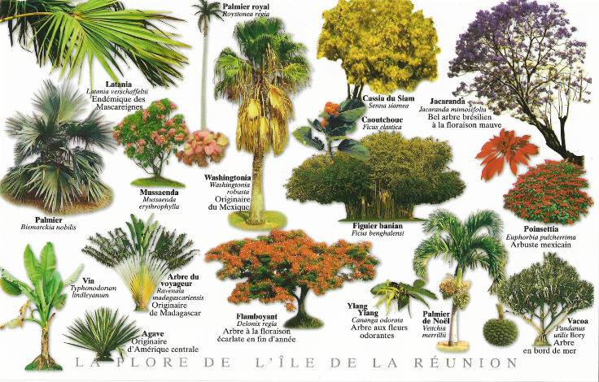
Colorful flowers

Local wildlife
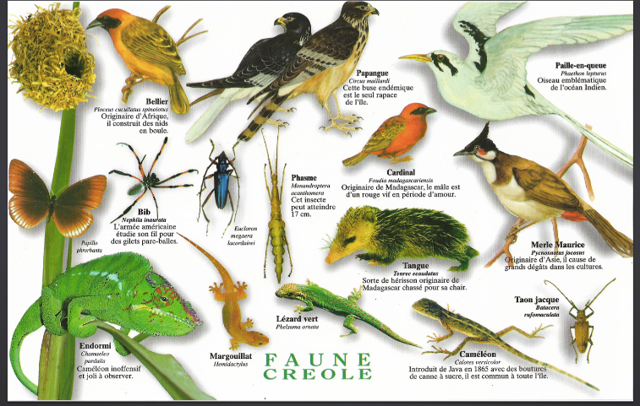

Buildings
Generally, the residential habitats are all wooden houses.
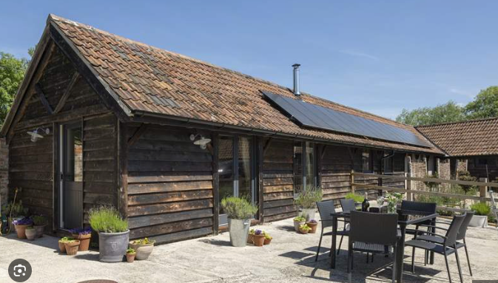 | 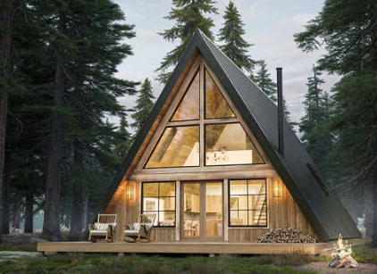 | 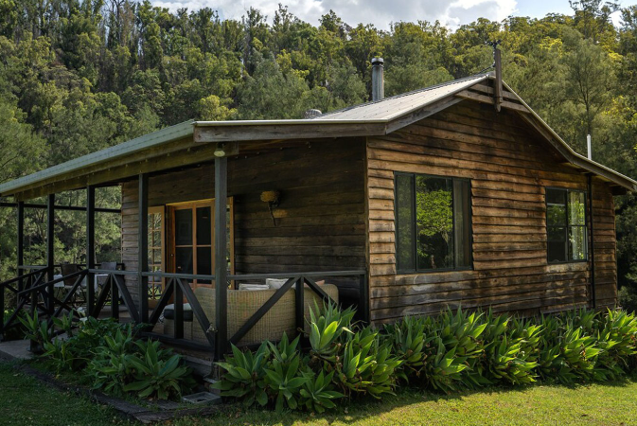
The School, Castle, and Lighthouse are made of stone.

Islands Specific

Village Island
An island with some wooden houses and rich in vegetation.
- Palm trees
- Ferns
- Sandy beach on one side
- Cliff on the other side
- Wooden houses, cottages, cutesy and peaceful.

Points of Interest:
- A small, currently uninhabited house where Yuhe can stay.
- A shop.
- Jackie's House
- Shen Yue's House
- There's a fairly large pier where boats come and go. The pier is guarded.

School Island
The front half of the island is flat and low, with a beach at the seaside.
- This is almost filled by the School.
The back half of the island is a mountain.
- The mountain forms the northern border of the school. It has a cave entrance at an unreachable spot in the mountain wall.

Point of interest - School:
- Various buildings for teaching, dining, and dormitories. These buildings are cutesy and can be made of stone and roof tiles.
- There's moderate vegetation of palm trees and plants.
- On the south side, there is a main entrance gate with a guard.
- A pier is at the main gate's side of the island.

Point of interest - Cave:
- The Cave is dark and scary.
- The inside of the cave has tunnels and rooms.
- Things can be written or painted on the walls.
- There are bones (animal/human) and torn pieces of cloth and other signs of death and killing scattered through the cave.
A monster shooter game can be inside the rooms of the cave.

Rocky/Castle Island
A very rocky island with only one large building: a castle.
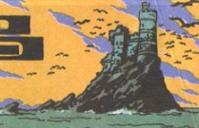 | 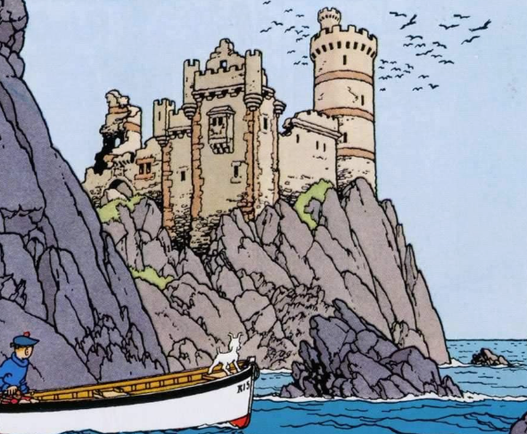
The castle is a European medieval style, but it's integrated into the surroundings.
There is a pier that connects directly to the Castle's entry bridge.
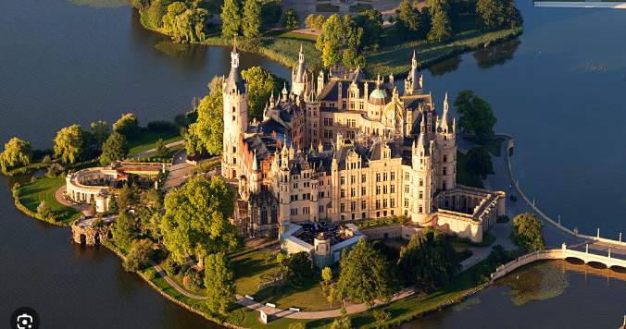 | 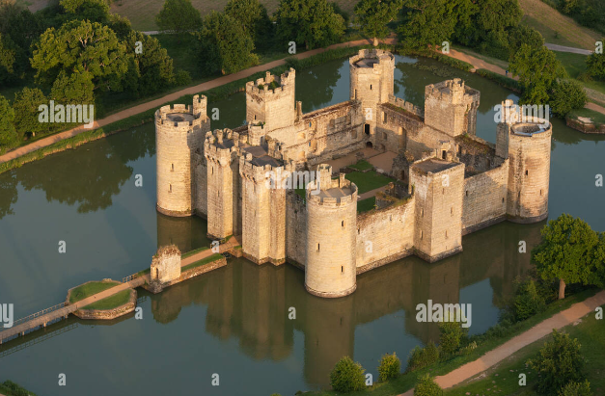
The castle has 2-4 towers.

Inside The Castle:
The medieval style is kept. The castle's inside has 3 floors: a cellar (dungeon) floor, a ground floor, and a top floor. The top floor gives access to the 2-4 towers that the player has seen from the outside.

The dungeon is a Pac-Man-style maze with zombies, where a treasure is to be found.
The zombies are all the kids from school. The player has to cure them by shooting them.

Cave Island
An island with a (hidden?) cave. The island looks like a volcano (like this, but without the smoke)
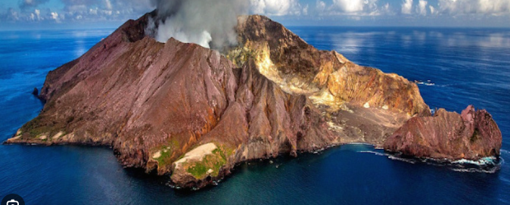
The cave can be reached via the inside of the Volcano.
There are dark rocks (rocky pathways) and streams of red-orange Lava inside.
There is a puzzle game here in which the player has to cross Lava streams by building plank bridges, or maybe there can be large levers to control Lava levels going up and down. (TBD)

Lighthouse Island

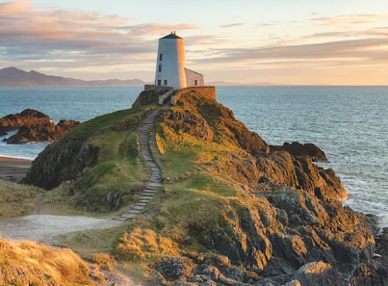 | 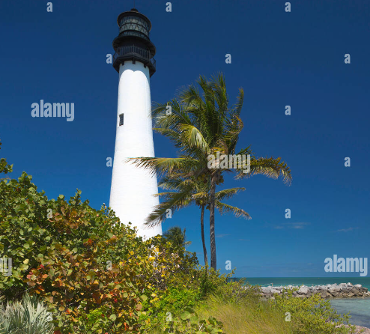
A small island with only a lighthouse on it, in the middle.
The island has no beach; all sides have cliffs.
There is a broken pier where no boat can park.

The Sea
A blue sea, through which a boat can traverse.
Traveling from island to island happens by sea. There is a boat going to all of the islands except Lighthouse Island. It can't be reached by boat because the Sea Monster is blocking the way; it lives here.
To get to Lighthouse Island, the player has to parasail (parachute pulled by a dolphin, and the player hangs from the parachute).
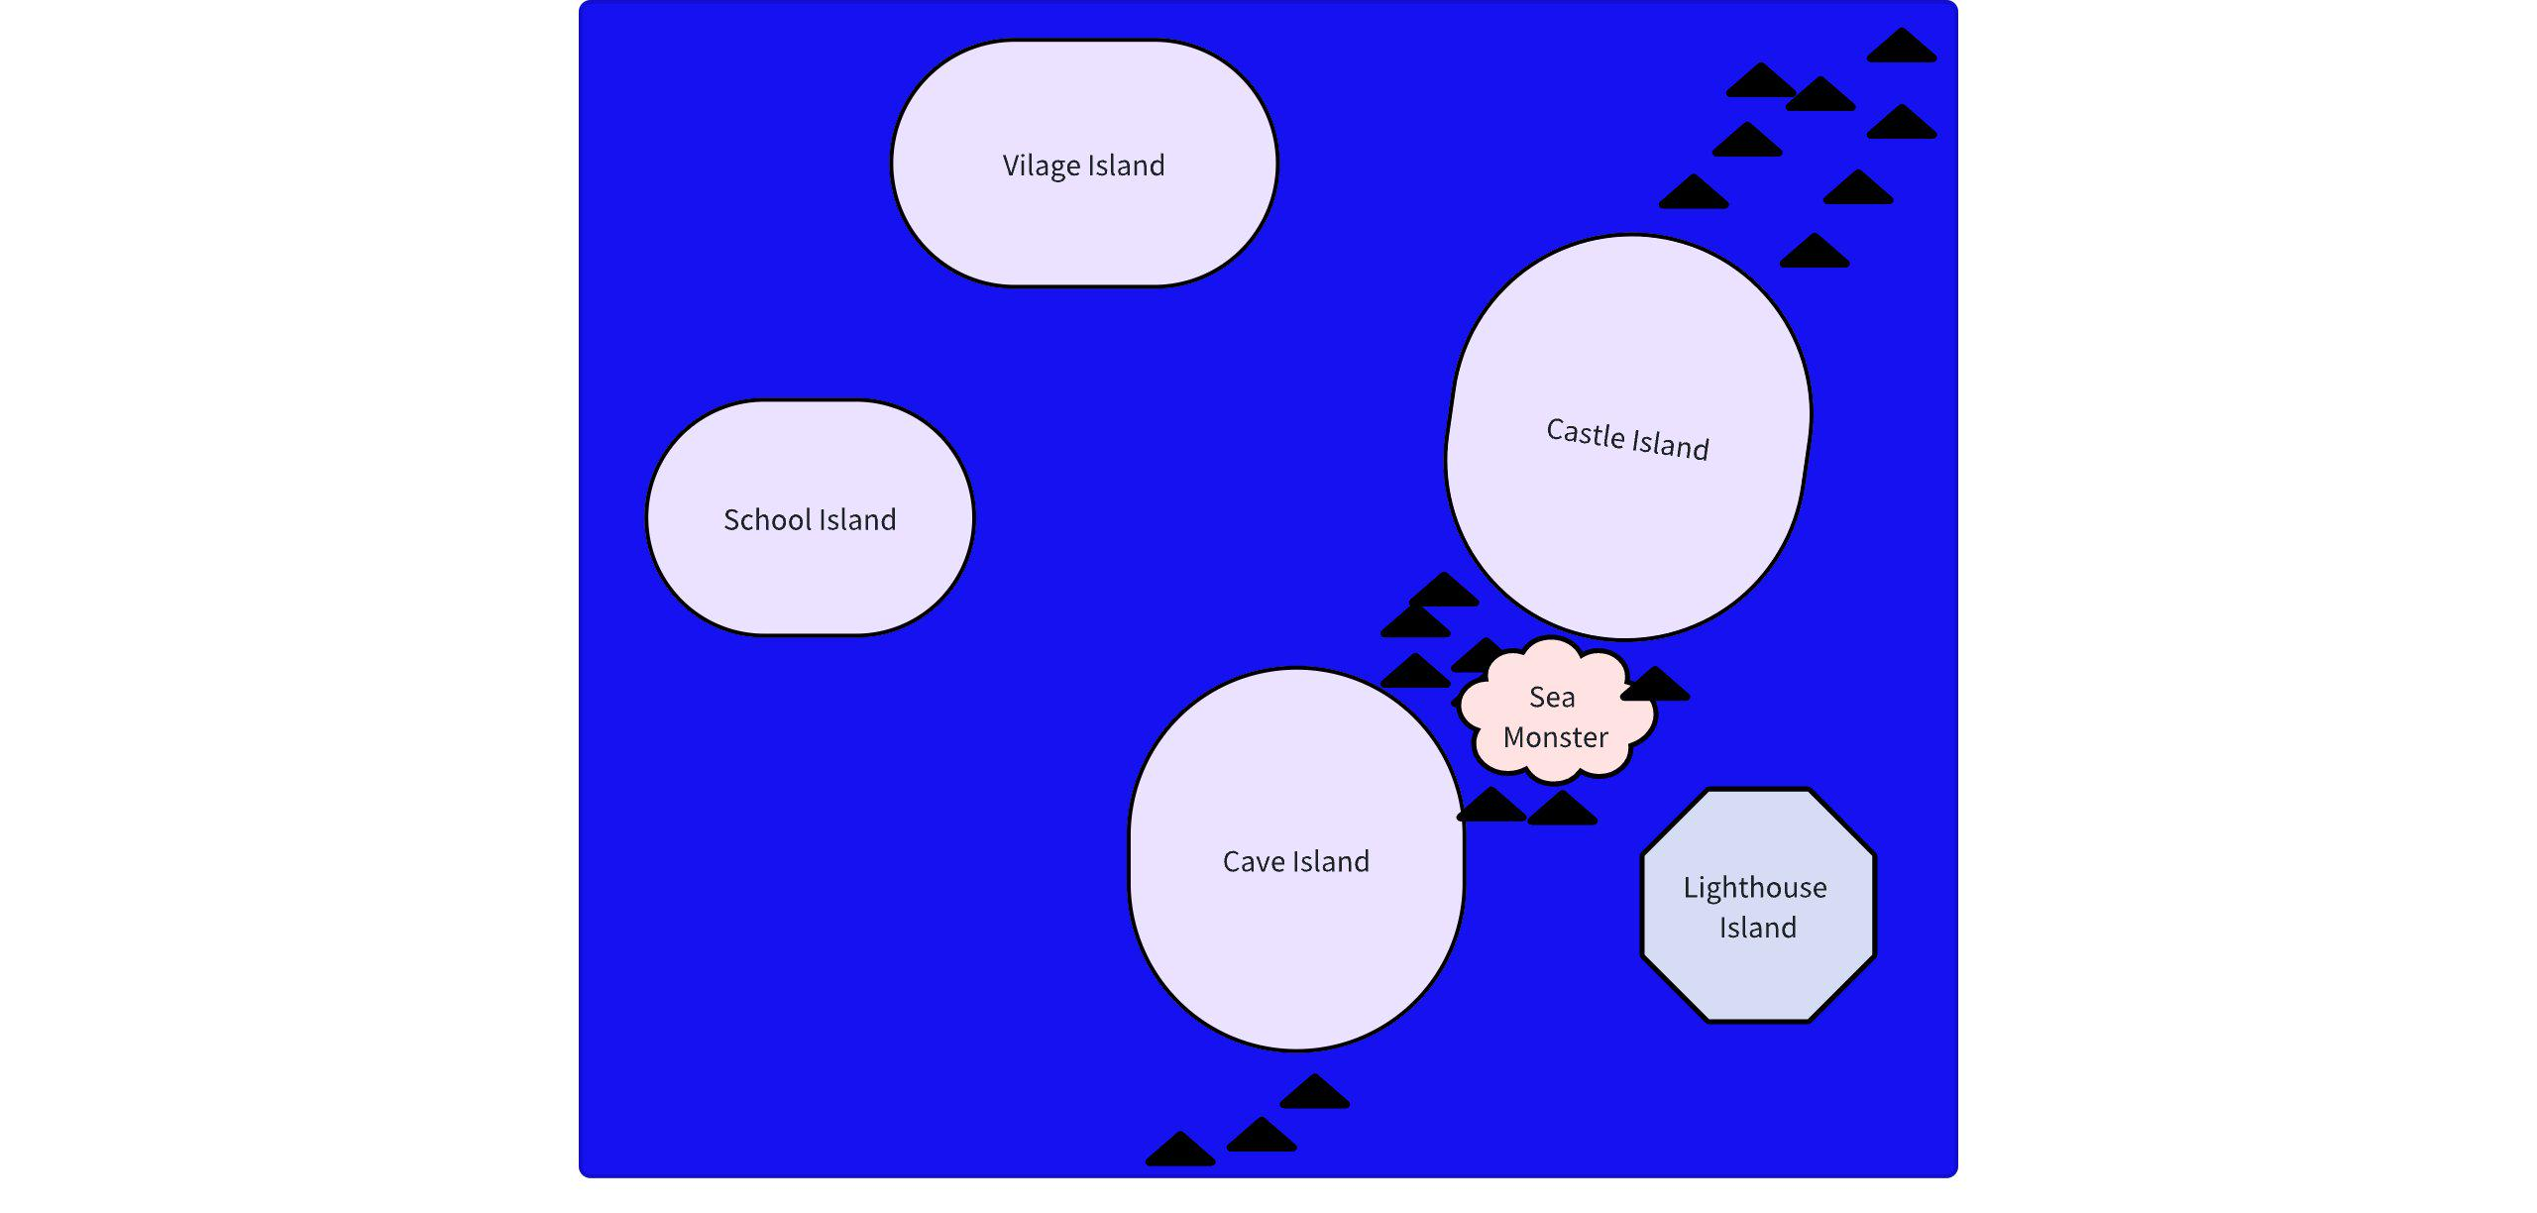

Inhabitants of the Islands

People
The islands are inhabited by human people.

Sea Monster
A Sea Monster lives in the sea near the islands, close to Lighthouse Island.
It is a cross-over between a giant fish and a Kraken. It has tentacles.
The Sea Monster goes to the Lighthouse Island once per year to collect a kid from it and eat the kid.

Legend Of The Sea Monster
According to the legend, a CURSE has been cast over the people of the island that causes children to turn into zombies and be attracted to the mysterious Lighthouse on Lighthouse Island. This explains why children occasionally disappear, never to be heard of again. The legend also states that one day, a young innocent girl with long black hair would fall from the sky during a solar eclipse. This girl will be the one to lift the curse.

